Construction Quotation 2025
ljqm]tfsf] gfd M ===============================================================================
Joj;fosf] gfd M ===============================================================================
PAN/VAT Number: ===============================================================================
7]ufgf M ===============================================================================
;Dks{ g+= M ===============================================================================
S.N. | Particulars | Unit | Quantity | Rate with 13% VAT | Remarks/ Brand Name
A | Hardware Materials
 | Water Tank (500 ltr) | Pcs | 1 |  | Brand: …………………..
 | Water Tank (1000 ltr) | Pcs | 1 |  | Brand: …………………..
 | Water Tank (2000 ltr) | Pcs | 1 |  | Brand: …………………..
 | Water Tank (3000 ltr) | Pcs | 1 |  | Brand: …………………..
 | Water Tank (5000 ltr) | Pcs | 1 |  | Brand: …………………..
 | Water Tank (10000 ltr) | Pcs | 1 |  | Brand: …………………..
 | BRASS BIB TAP | Pcs | 1 |  | 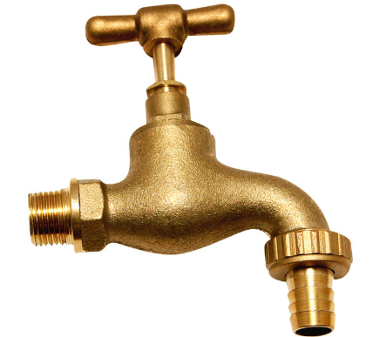
 | Bib Tap Brass Faucet | Pcs | 1 |  | 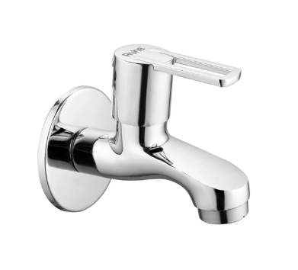
 | Welding Rods 2.5 (5kg) | KG | 1
 | CPVC Pipe 1/2 " | Pcs | 1
 | CPVC Pipe 3/4 " | Pcs | 1
 | CPVC Pipe 1" | Pcs | 1
 | HDPE Pipe 1" | Meter | 1
 | HDPE Pipe 1/2" | Meter | 1
 | HDPE Pipe 3/4" | Meter | 1
 | HDPE Pipe 1.5" | Meter | 1
 | HDPE Pipe 2" | Meter | 1
 | HDPE Pipe 2.5" | Meter | 1
 | CP Grating 5" Jali | Pcs | 1
 | CPVC Socket 1 " | Pcs | 1
 | CPVC Socket ½ " | Pcs | 1
 | CPVC Socket 3/4" | Pcs | 1
 | CPVC Reducing 1" *1/2" | Pcs | 1
 | CPVC Reducing1/2" * 3/4" | Pcs | 1
 | CPVC Elbow 1/2 " | Pcs | 1
 | CPVC Elbow 3/4 " | Pcs | 1
 | CPVC Elbow 1" | Pcs | 1
 | CPVC Tee 1/2 " | Pcs | 1
 | CPVC Tee 3/4 " | Pcs | 1
 | CPVC Tee 1" | Pcs | 1
 | CPVC Ball valve 1/2" | Pcs | 1
 | CPVC Ball valve 3/4" | Pcs | 1
 | CPVC Ball valve 1" | Pcs | 1
 | CPVC Brass Elbow 3/4" | Pcs | 1
 | CPVC Union 1/2" | Pcs | 1
 | CPVC Union 3/4" | Pcs | 1
 | CPVC Union 1" | Pcs | 1
 | CPVC Tank connector 3/4" | Pcs | 1
 | CPVC Tank connecter 1" | Pcs | 1
 | CPVC Brass Female socket 3/4" | Pcs | 1
 | CPVC Brass Female socket 1" | Pcs | 1
 | CPVC Pipe Solvent (250 ml) | Pcs | 1
 | Cutting wheel | Pcs | 1
 | UPVC RCC Nail Clamp | Pcs | 1
 | 1" Iron Flat Bar | KG | 1
 | 1"*1" Iron Angle | KG | 1
 | 1.5"*1.5" Iron Angle | KG | 1
 | Cotton Thread | Packet | 1
 | Wall Tiles | Sq/Ft | 1
 | Floor Tiles | Sq/Ft | 1
 | Cement OPC 53 grades | Bag | 1
 | Cement PPC 43 grades | Bag | 1
 | White Cement | kG | 1
 | Gi Wire | KG | 1
 | Premium wall paint - Olive Green | Liter | 1
 | Primer- wall | Liter | 1
 | PVC Pipe 49 mm | M | 1
 | PVC Pipe 75mm | M | 1
 | Non-Color GI sheets (26 Gauge,0. 43 mm thick) | Bundle | 1
 | Color GI sheets (26 Gauge,0. 50 mm thick) | Bundle | 1 |  | Brand: …………………..
 | Plain Sheet Color | M | 1
 | GI Gate Valve 3/4" | Pcs | 1
 | GI Gate Valve 1" | Pcs | 1
 | CPVC Gate Valve 3/4" | Pcs | 1
 | CPVC Gate Valve 1" | Pcs | 1
 | Iron rod (TMT bars) 8mm | kG | 1
 | Iron rod (TMT bars) 10mm | kG | 1
 | Iron rod (TMT bars) 12mm | kG | 1
 | Iron rod (TMT bars) 16mm | kG | 1
 | Thread Tape | Pcs | 1
 | J- Hook Bolt | KG | 1
 | Cast Iron Round Pipe 75 mm | KG | 1
 | Binding Wire | KG | 1
 | Wall painting Roller brush 6” | Pcs | 1
 | Wall painting Flat brush 3” | Pcs | 1
 | Enamel Paint for Metal | Liter | 1
 | Rubber or Plastic Washers (Roofing Nails) | Pcs/Packet | 1
 | GI Tank connecter 1 " | Pcs | 1
 | GI Tank connecter 1.5 " | Pcs | 1
 | GI Tank connecter 2 " | Pcs | 1
 | GI Tank connecter 2.5 " | Pcs | 1
 | GI Socket 1.5 " | Pcs | 1
 | GI Socket 2 " | Pcs | 1
 | GI Socket 2.5 " | Pcs | 1
 | HDPE PIPE Clamp Saddle 1 " Reducing | Pcs | 1
 | HDPE PIPE Clamp Saddle 1.5 " Reducing | Pcs | 1
 | HDPE PIPE Clamp Saddle 2 " Reducing | Pcs | 1
 | HDPE PIPE Clamp Saddle 2.5" Reducing | Pcs | 1
 | HDPE Equal Tee 1 " | Pcs | 1
 | HDPE Equal Tee 1.5 " | Pcs | 1
 | HDPE Equal Tee 2 " | Pcs | 1
 | HDPE Equal Tee 2.5" | Pcs | 1
 | HDPE Elbow 1 " | Pcs | 1
 | HDPE Elbow 1.5 " | Pcs | 1
 | HDPE Elbow 2 " | Pcs | 1
 | HDPE Elbow 2.5 " | Pcs | 1
 | Galvanized KHUKRE Jali 2x2 inch Height 6 ft | Mtr | 1 |  | 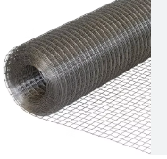
 | Galvanized KHUKRE Jali 2x2 inch Height 4 ft | Mtr | 1
 | Conceit Nail 1.5" | Kg | 1
 | Conceit Nail 2" | Kg | 1
 | Conceit Nail 3" | Kg | 1
 | Nail 2" KATI | Kg | 1
 | Iron Nails 3"KATI | Kg | 1
 | Iron Nails 4" KATI | Kg | 1
 | Door Pull Handel | Pcs | 1 |  | 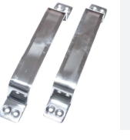
 | Stainless Steel Window & Door Butt Hinges KABJA | Pcs | 1 |  | 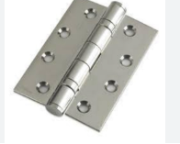
 | Aluminum Tower Bolt 4 inch Chukkul | Pcs | 1 |  | 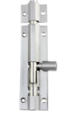
 | Door Chukkul Normal | Pcs | 1 |  | 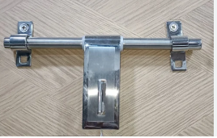

cfjZos sfuhftx? M
!= PAN/VAT btf{sf] sfuhkq, x:tfIf/
@= Joj;fo kmd{ btf{ k|df0f kq 5fk M
#= cf=j= @)*!/*@ sf] s/ r''Qmfsf] k|df0f kq ldlt M
$= gljs/0f k|df0fkqsf] k|ltlnlk
%= cfkm\gf] ;+:yfsf] n]6/ Kof8df sf]6]zg k]z u/]sf] hfgsf/L kq .

