b/efp kq Quotation
ljqm]tfsf] gfdM
Joj;fosf] gfdM
PAN/VAT No:
7]ufgfM
;Dk{s g+ M

qm=; | ;fdfu|L | ljj/0f | kl/df0f | d'No | s}lkmot
! | Fevicol 250gm | Pcs | 1
@ | Fevicol 500gm | Pcs | 1
# | Door Pull Handel | Pcs | 1 |  | 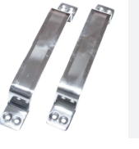
$ | Stainless Steel Window & Door Butt Hinges KABJA | Pcs | 1 |  | 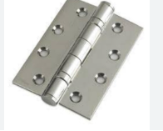
% | Aluminum Tower Bolt 4 inch Chukkul | Pcs | 1 |  | 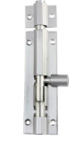
^ | Door Chukkul Normal | Pcs | 1 |  | 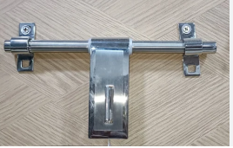
& | Ply Wood 6 mm | Pcs | 1
* | Plywood12 mm | Pcs | 1
( | Plywood 18 mm | Pcs | 1
!) | Plain Sunmica 1mm | Pcs | 1

cfjZos sfuhftx?M 5fkM
!= PAN/VAT btf{sf] sfuhft x:tfIf/M
@= Joj;fo ÷kmd{ btf{ k|df0f kq ldltM
#= cf=j= @)*!÷*@ sf] s/ r'Stfsf] k|df0f kq .
$= gljs/0f k|df0fkqsf] k|ltlnkL .
%= sf]6]zg k]; u/]sf] hfgsf/L ;+:yfsf] n]6/ Kof8df .

