Quotation Publication
ljqm]tfsf] gfdM =====================================================================
Joj;fosf] gfdM =====================================================================
PAN/VAT No: =====================================================================
7]ufgfM =====================================================================
;Dk{s g+M =====================================================================

SN | Items | Specification | Unit | Quantity | Rate (Per Pcs rate Including 13% VAT) | Remarks
1 | krf{ Pamphlet | Paper Size: 12*8''  Color Paper  Paper Quality: 44 Grm | Pc | 1 |  | Approx Printing copy 5000
2 | krf{ Pamphlet | Paper Size: 6*8''  Color Paper  Paper Quality: 44 Grm | Pc | 1 |  | Approx Printing copy 5000
3 | Poster | Paper Size: 15*20  Color: Multi Color (4 Color)  Paper Quality: 130grm | Pc | 1 |  | Approx Printing copy 3000
4 | Poster | Paper Size: 15*20  Sticker Paper with Lamination  Multicolor | Pc | 1 |  | Approx Printing copy 3000
5 | Token of Love | 1. Print Design: 7.5cm/10cm with plastic laminated  2. silver colored paper | Pc | 130
Sample of Token of Love:
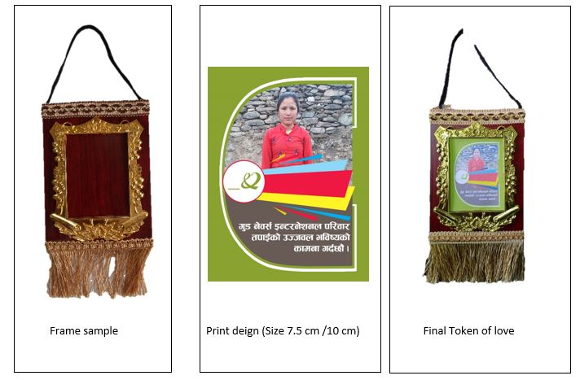



Note: If any discount in whole required 130+ quantities, please mention below.

cfjZos sfuhftx? M
!= PAN/VAT btf{sf] sfuhkq, x:tfIf/
@= Joj;fo kmd{ btf{ k|df0f kq 5fk M
#= cf=j= @)*!/*@ sf] s/ r''Qmfsf] k|df0f kq ldlt M
$= gljs/0f k|df0fkqsf] k|ltlnlk
%= cfkm\gf] ;+:yfsf] n]6/ Kof8df sf]6]zg k]z u/]sf] hfgsf/L kq .

